INSTALL GIT

* Let's install GIT. First, identify the operating system this lab environment is built on.

$ cat /etc/*release*

DISTRIB_ID=Ubuntu

DISTRIB_RELEASE=18.04

DISTRIB_CODENAME=bionic

DISTRIB_DESCRIPTION="Ubuntu 18.04.4 LTS"

NAME="Ubuntu"

VERSION="18.04.4 LTS (Bionic Beaver)"

ID=ubuntu

ID_LIKE=debian

PRETTY_NAME="Ubuntu 18.04.4 LTS"

VERSION_ID="18.04"

HOME_URL="https://www.ubuntu.com/"

SUPPORT_URL="https://help.ubuntu.com/"

BUG_REPORT_URL="https://bugs.launchpad.net/ubuntu/"

PRIVACY_POLICY_URL="https://www.ubuntu.com/legal/terms-and-policies/privacy-policy"

VERSION_CODENAME=bionic

UBUNTU_CODENAME=bioni

* Install GIT on the system.

$ sudo apt update

$ sudo apt install git

$ sudo git init

Refer to the GIT installation documentation here: <https://git-scm.com/book/en/v2/Getting-Started-Installing-Git>

* Identify the version of git you just installed.

$ git --version

git version 2.17.1

* But let's see if you can figure some stuff out using the git help command. What's the git command used to Show various types of objects?

$ git help

usage: git [--version] [--help] [-C <path>] [-c <name>=<value>]

[--exec-path[=<path>]] [--html-path] [--man-path] [--info-path]

[-p | --paginate | --no-pager] [--no-replace-objects] [--bare]

[--git-dir=<path>] [--work-tree=<path>] [--namespace=<name>]

<command> [<args>]

These are common Git commands used in various situations:

start a working area (see also: git help tutorial)

clone Clone a repository into a new directory

init Create an empty Git repository or reinitialize an existing one

work on the current change (see also: git help everyday)

add Add file contents to the index

mv Move or rename a file, a directory, or a symlink

reset Reset current HEAD to the specified state

rm Remove files from the working tree and from the index

examine the history and state (see also: git help revisions)

bisect Use binary search to find the commit that introduced a bug

grep Print lines matching a pattern

log Show commit logs

show Show various types of objects status Show the working tree status

grow, mark and tweak your common history

branch List, create, or delete branches

checkout Switch branches or restore working tree files

commit Record changes to the repository

diff Show changes between commits, commit and working tree, etc

merge Join two or more development histories together

rebase Reapply commits on top of another base tip

tag Create, list, delete or verify a tag object signed with GPG

collaborate (see also: git help workflows)

fetch Download objects and refs from another repository

pull Fetch from and integrate with another repository or a local branch

push Update remote refs along with associated objects

'git help -a' and 'git help -g' list available subcommands and some

concept guides. See 'git help <command>' or 'git help <concept>'

to read about a specific subcommand or concept.

* What's the git command used to List, create, or delete branches?

$ git branch

* What's the git command used to Download objects from another repository?

$ git fetch

* What's the git command used to start a working area?

$ git init

* You may view additional help on each command following the syntax git help <command>. For this you must first install git man pages using the command sudo apt-get install git-man

Once done use the help of the init command with the command git help init and identify the option used to create a bare repository.

$ sudo git help init

A doc with git init manual will appear and for bare we use

$ sudo git init --bare

INTIALIZE A GIT REPO

* Command to initialize git

$ git init

* Initialize a git repository at /home/sarah/story-blog

sarah $ pwd

/home/sarah

sarah $ mkdir /home/sarah/story-blog

sarah $ cd story-blog/

sarah $ git init

hint: Using 'master' as the name for the initial branch. This default branch name

hint: is subject to change. To configure the initial branch name to use in all

hint: of your new repositories, which will suppress this warning, call:

hint:

hint: git config --global init.defaultBranch <name>

hint:

hint: Names commonly chosen instead of 'master' are 'main', 'trunk' and

chint: 'development'. The just-created branch can be renamed via this command:

hint:

hint: git branch -m <name>

Initialized empty Git repository in /home/sarah/story-blog/.git/

* Which hidden folder gets created after initializing a git repository?

.git

* Once a git repository has been initialized, which stage contains the active changes in your local git repository?

Working area

* Let’s add a file to our project inside /home/sarah/story-blog

File name: lion-and-mouse.txt

File content: A Lion lay asleep in the forest

sarah $ touch lion-and-mouse.txt

sarah $ echo "A Lion lay asleep in the forest" > lion-and-mouse.txt

* Which stage contains new changes that will soon be committed to local git repo ?

Staging Area

* sarah $ git status

On branch master

No commits yet

Untracked files:

(use "git add <file>..." to include in what will be committed)

lion-and-mouse.txt

nothing added to commit but untracked files present (use "git add" to track

* What's the status of the lion-and-mouse.txt file in the repository?

Untracked

* Which area of the local git repository is the lion-and-mouse.txt file in ?

Working area

* Stage the file lion-and-mouse.txt to make it available for commit.\

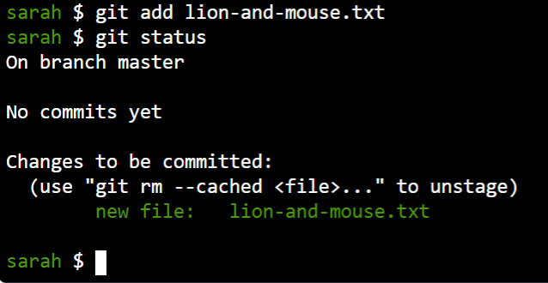

* Now, it's time to commit our change! A commit records the change in the repository compared to its previous state. But before that we must configure the git user who will be the owner of the commit.

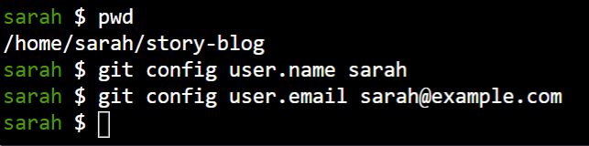

* Let's commit our change! In this case, we didn't have any previous commits,  
  so the addition of the file lion-and-mouse.txt is a change compared to its previous state.  
  Commit the files that are currently in the staging area.

First check the status of the file using the command git status. Then commit using the commit message as Added the lion and mouse story

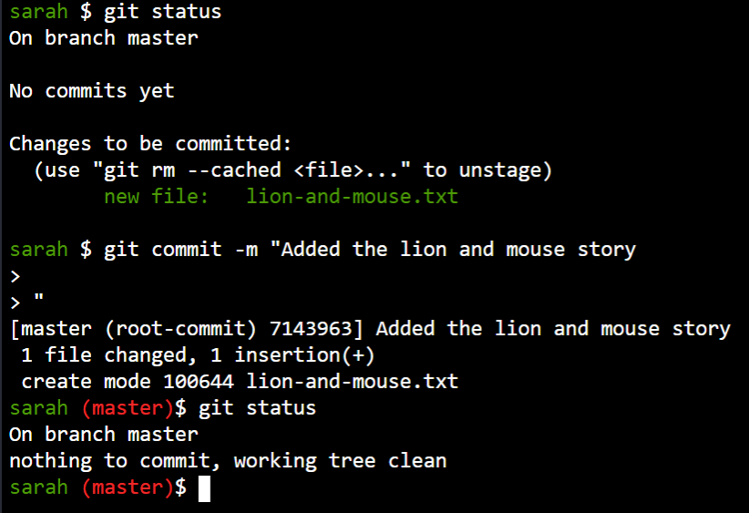

* Sarah created a new file named notes.txt where she plans to write down ideas about the story for personal purposes. She does not want git to track this file or share it with her team mates.

What is the current status of the notes.txt file?

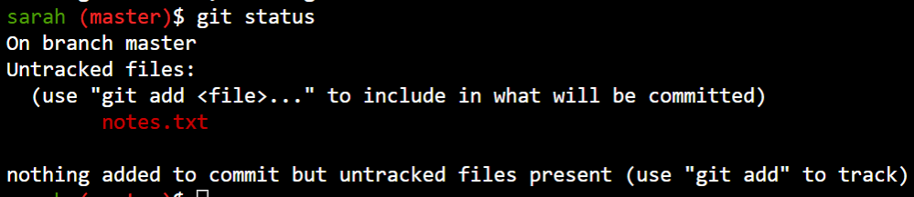

* It is good that the file is untracked. But it is still under GIT's radar. If you run the "git add ." command accidentally git will start to track this file.

Let's configure git to ignore this file permanently.

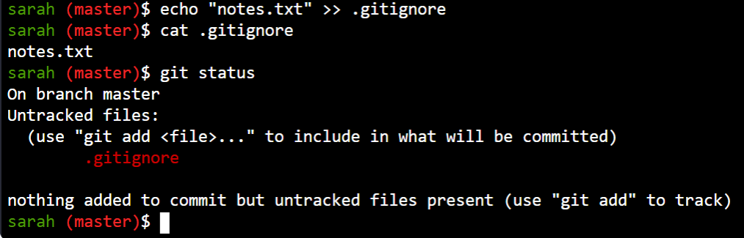

Not listed now notes.txt in gitstatus

* As you might have noticed the .gitignore file itself may be listed as untracked. It is a good practice to track the .gitignore file with git.
* Let's explore another git repository. We have a repository used for the development of an application cloned at /home/sarah/learning-app-ecommerce.

Identify the state of the git repository. How many files are staged and how

many are not?

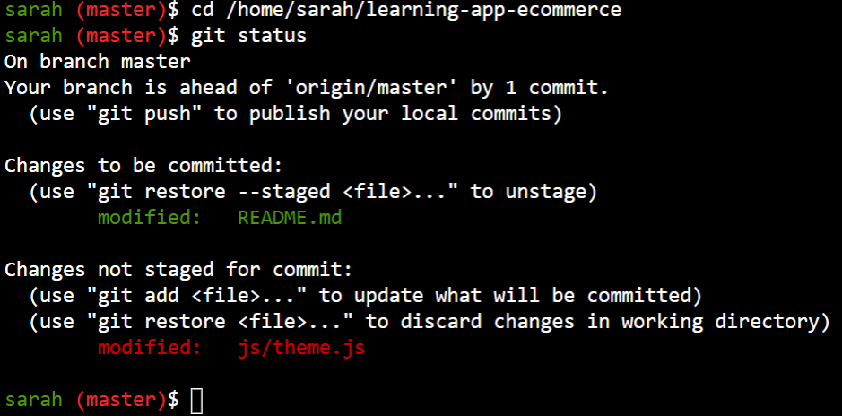

1 staged & 1 modified

* You are asked to commit the README.md file with the commit message Add instructions for verification and the js/theme.js file with the message Increase time from 400 to 500

Note that the README.md file is already staged. So you just have to commit it. The file js/theme.js is to be committed as part of another commit.

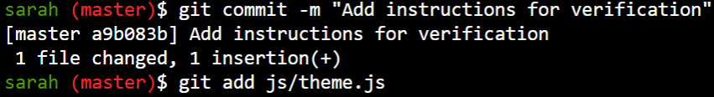 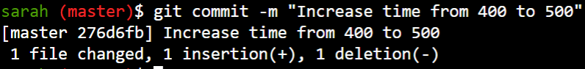

* What files are configured to be ignored by this repository?

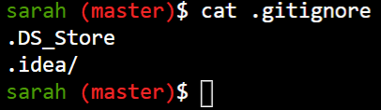

GIT LOG

* We have initialised git repo in /home/sarah/story-blog. Check git log command output in that directory

Simply run cd /home/sarah/story-blog; git log

As we haven't commited any file yet it should show message fatal: your current branch 'master' does not have any commits yet . So lets commit some file in next step.

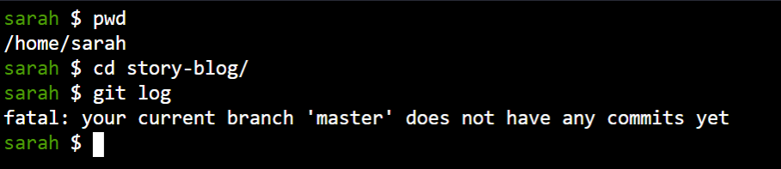

* Sarah has written a story lion-and-mouse.txt under /home/sarah/story-blog/. Please commit it to local git repo

Add commit message: Added the lion and mouse story

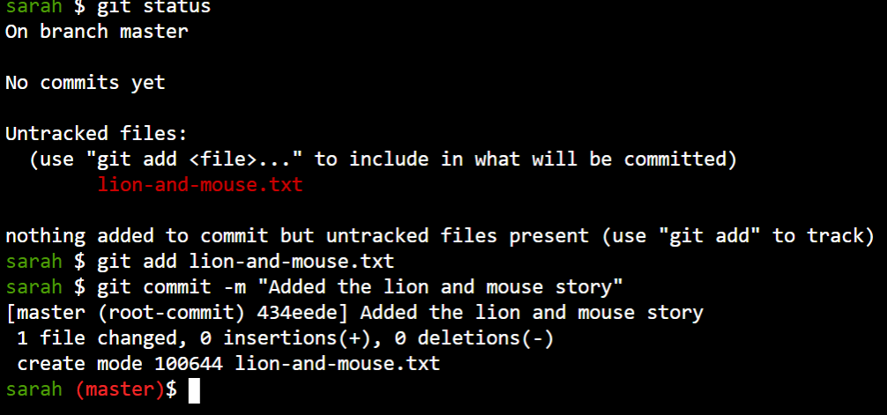

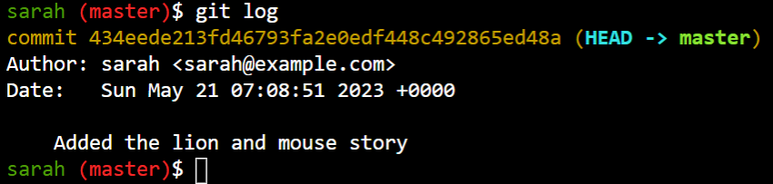

* Which info is not displayed in git log?

List of changed files are not present in log

--name-only prints the name of file xtra and –oneline shows in oneline

* Which branch has the changes been committed to?

Branch info can be seen in first line of git log output where (HEAD -> {BRANCH_NAME} ) is displayed.

Master 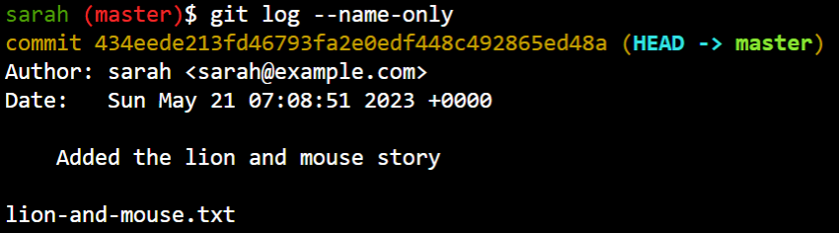 

* Who is the new author who commited with file name

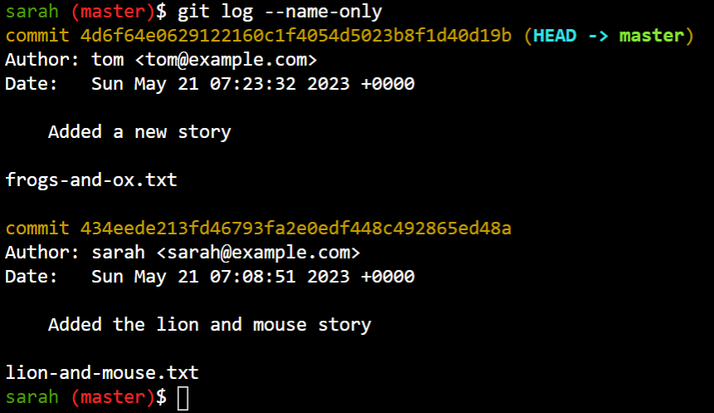

* What is the option for git log command to display the logs in compact way (one log per line)?

$ git log –oneline

The repository has many commits. Can you try to list the last 3 commits alone?

There should be an option in git log to limit the list of outputs. Use git help log. Check hint if not sure.

* Identify who made the latest commit in the new repository.

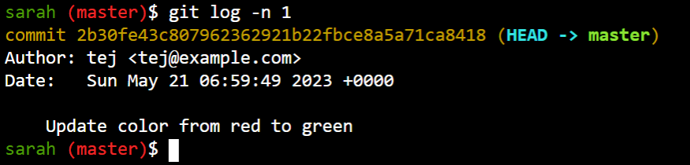

* Judging by their actions, can you guess who may be the javascript developer in the team?

Look at the logs and identify the person who made changes to the .js file recently. You have already learned the option to display files associated with a commit

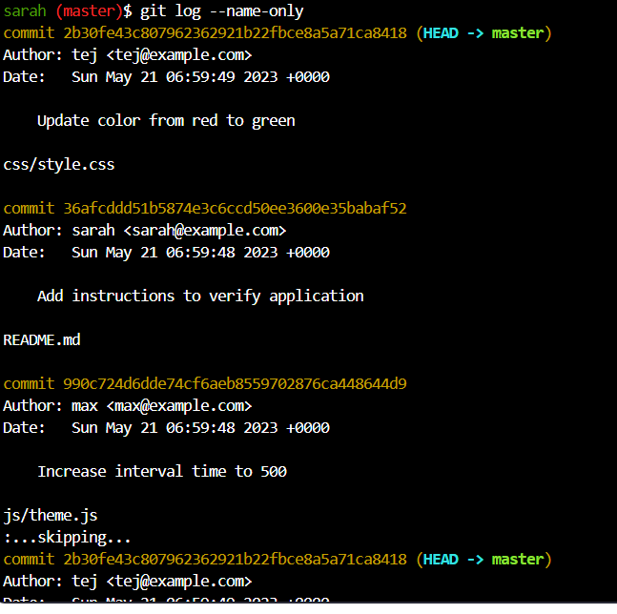

MAX

GIT BRANCH

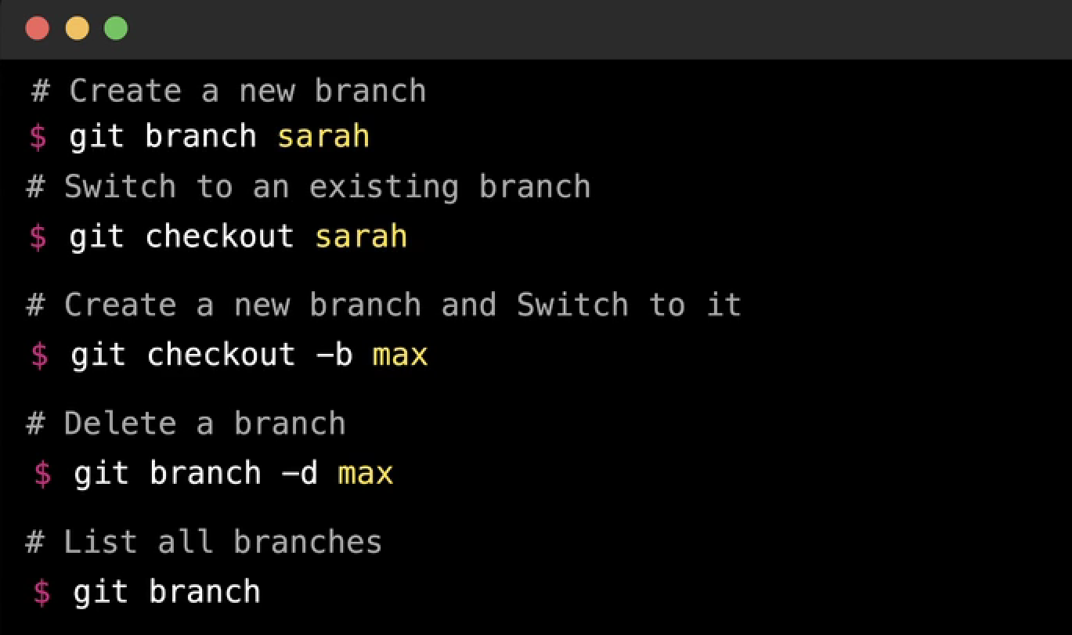

* What is a branch in git?

A pointer to a specific commit in git is a branch

* What is the default branch of a git repository?

Master

* Sarah has been working on a git repo at /home/sarah/story-blog and has written a short story. Check git log command output in that directory to see the activity.

What's the name of the file created by Sarah?

Lion-and-mouse.txt

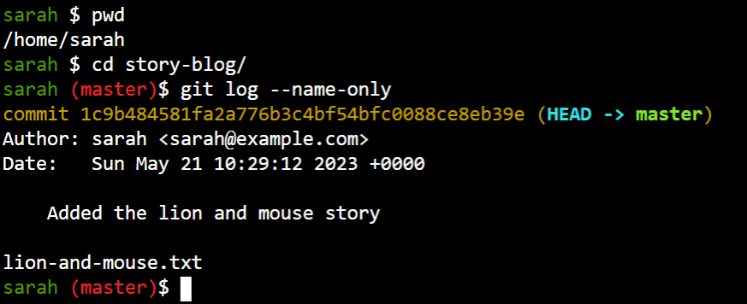

* To which branch is the 🦁 lion-and-mouse.txt 🐭 file committed to in the git repository?

Master

* Sarah decides to write a new story - 🐸 The Frogs and Ox 🐂. Let's create and checkout a new branch named story/frogs-and-ox



* View the output of the git log command and identify the branch to which HEAD is pointing to now.



* Max informs Sarah that in her first story there's a typo in the title and needs to be fixed ASAP!

We must go back and fix the story in the master branch. But before we do that, let's commit the new story we have written so far. We don't want to carry our incomplete story to the master branch.

Stage and commit the story with the message Add incomplete frogs-andox story

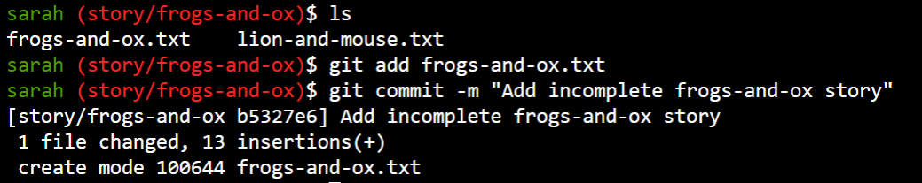

* Now checkout the master branch.

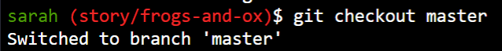

* Let's fix the typo in the lion-and-mouse.txt file. LION 🦁 is mis-spelt as LIOON. Please fix it and then commit the changes.

Commit message: Fix typo in story title

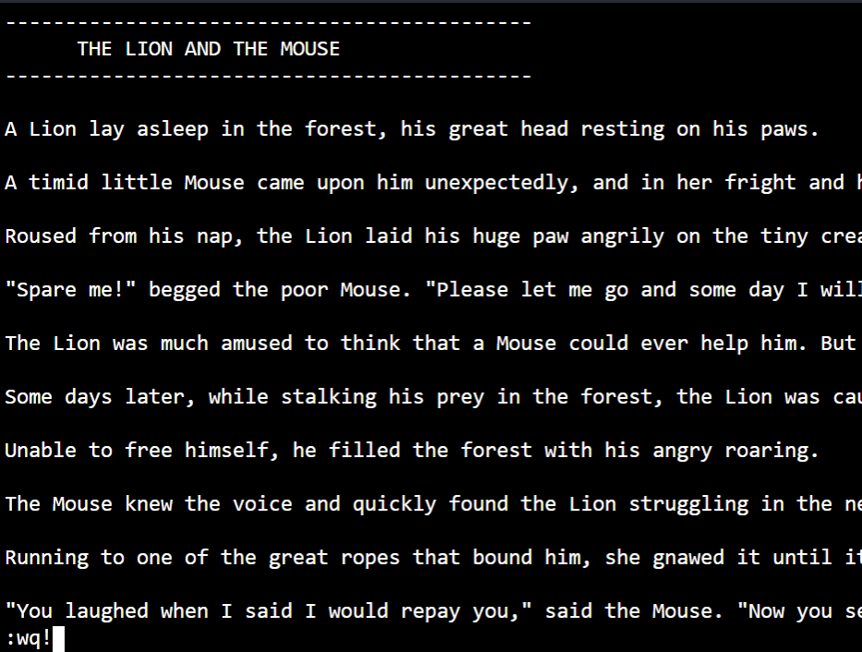

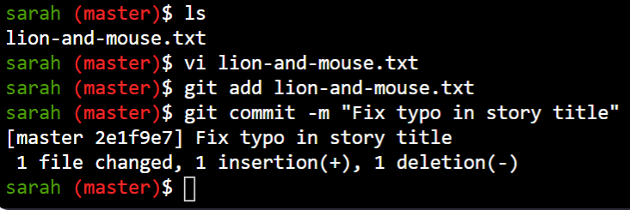

* Great! Now that it's out of the way, let's finish the 🐸 frogs-and-ox 🐂 story. Switch back to the story/frogs-and-ox branch.

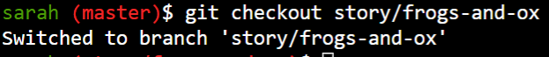

* Sarah has now finished her story. Check the changes and commit them with the message Completed frogs-and-ox story

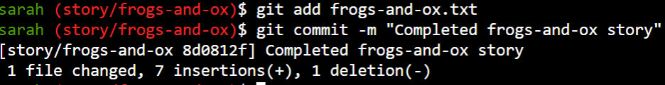

* A new git repository is created at the path /home/sarah/website for hosting the story website.

Count the number of branches available in that repository including the master branch.

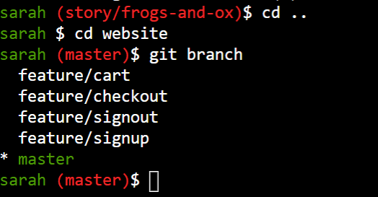

* Looking at the commit history, try to guess what branch was the feature/signout branch created from?

Checkout branch feature/signout and then use the command git log --graph --decorate to see previous commit history along with the branch they were committed on.

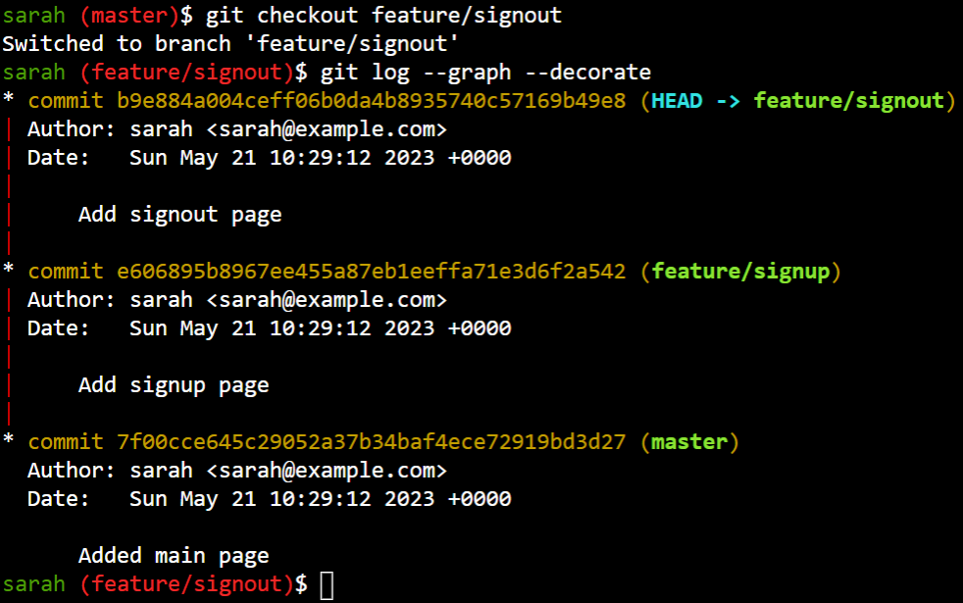

* Here's a fun one! Looking at the commit history of all branches, what's the best graphical representation of the branches in this repository?

Checkout each branch and then use the command git log --graph --decorate to see previous branch.

A.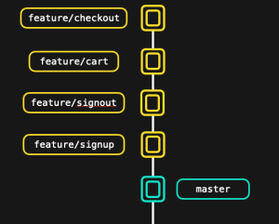

B.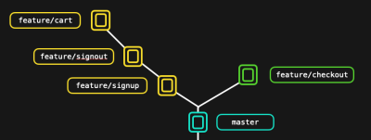

C.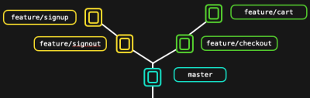

D.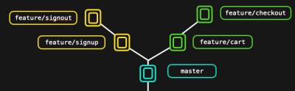

ANSWER IS D

GIT MERGE

2 types of merges:

FAST FORWARD MERGE- this can happen when a current branch has no xtra commit compared to the branch we are merging.This type of merge doesn’t create a commit rather but merges to commit on the branch that we’re merging right into current branch.

NO FAST FORWARD MERGE- this can happen when a current branch has xtra commit n git merges all changes with a final merge commit.

* Let's proceed with where we left off in the previous lab. Sarah's local repository should be available at /home/sarah/story-blog

How many stories are currently available in the master branch?

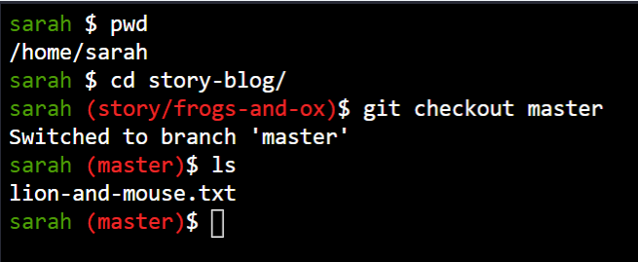

* What's the name of the story in the master branch?

Lion-and-mouse.txt

* How many branches does the repository currently have?

2

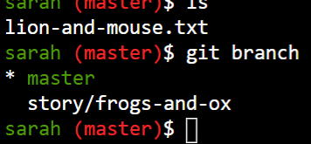

* The new story Sarah wrote is in the story/frogs-and-ox branch. It's time to merge the branch and bring it to the master branch.

But before that look at the log of the master and story/frogs-and-ox branches and identify how many commits there have been in the past on each branch. 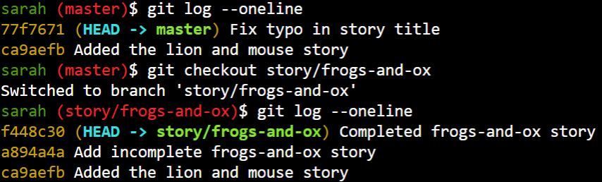

* While in the master branch merge the story/frogs-and-ox branch. If prompted for a commit message leave it to the default and quit the editor.

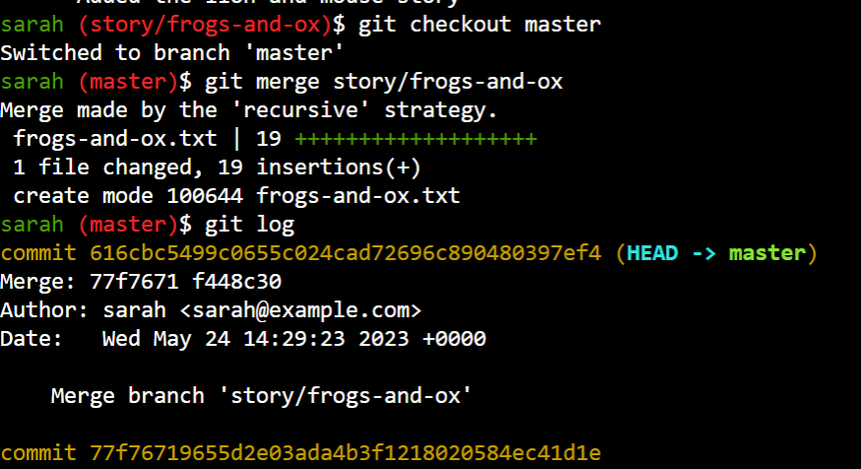

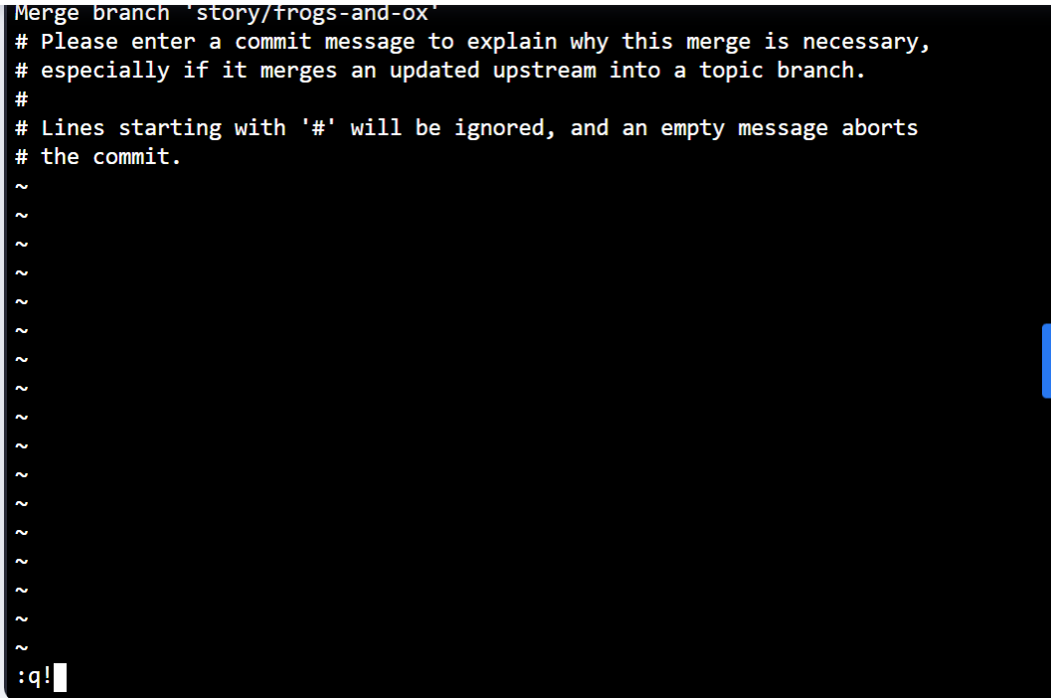

Git log sometimes show less info press arrow key to seeall commit near colon in screen

Git merged all the commits we made in the story/frogs-and-ox branch to the master branch. But since we made an additional commit on the master (fixing the typo from LIOON to LION) git created a new merge commit

* List the files in the master branch and make sure both the stories are visible.

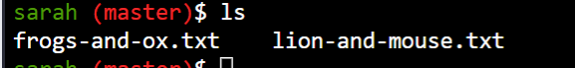

REMOTE REPOSITORY

* Explore the local repository that Sarah has been working on at /home/sarah/story-blog and check the log to see the number of commits.

5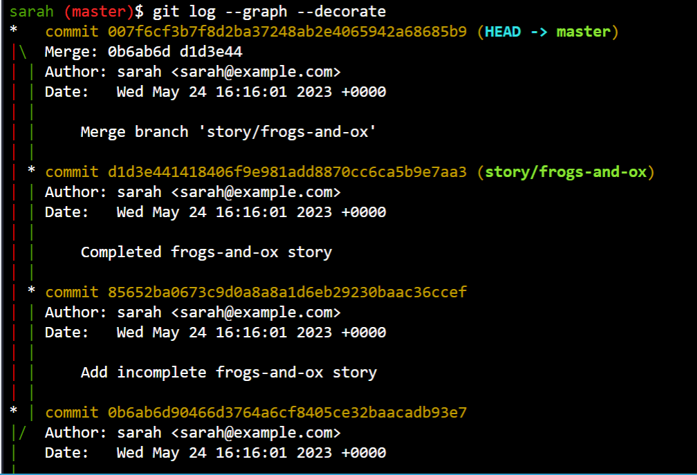

* How many stories has Sarah written so far?

Count the number of stories in the master branch

2

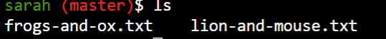

Great going Sarah 👏 ! So far Sarah has been working by herself in her own local repository on her laptop. It's time to share her work with the team. Let's push the code to the remote git repository.

Github is awesome! But for the purpose of our lab exercises we will be using the Gitea platform. It is a lighter version of Github. However a lot of basic functions are the same. So it should suffice our needs for practice.

You may access the Gitea web portal by clicking on the Git Portal UI link at the top of your terminal

No one in Sarah's team has created a remote repository yet for this project. So Sarah decides to create one so everyone in the team can collaborate. Let's now create a remote git repository named story-blog in Gitea using the GUI. Click on Git Portal UI to access the UI, login with the below details and create a new repository.

UI login info:

Username: sarah

Password: Sarah_pass123

Repository Name: story-blog

Keep other options default when creating repo

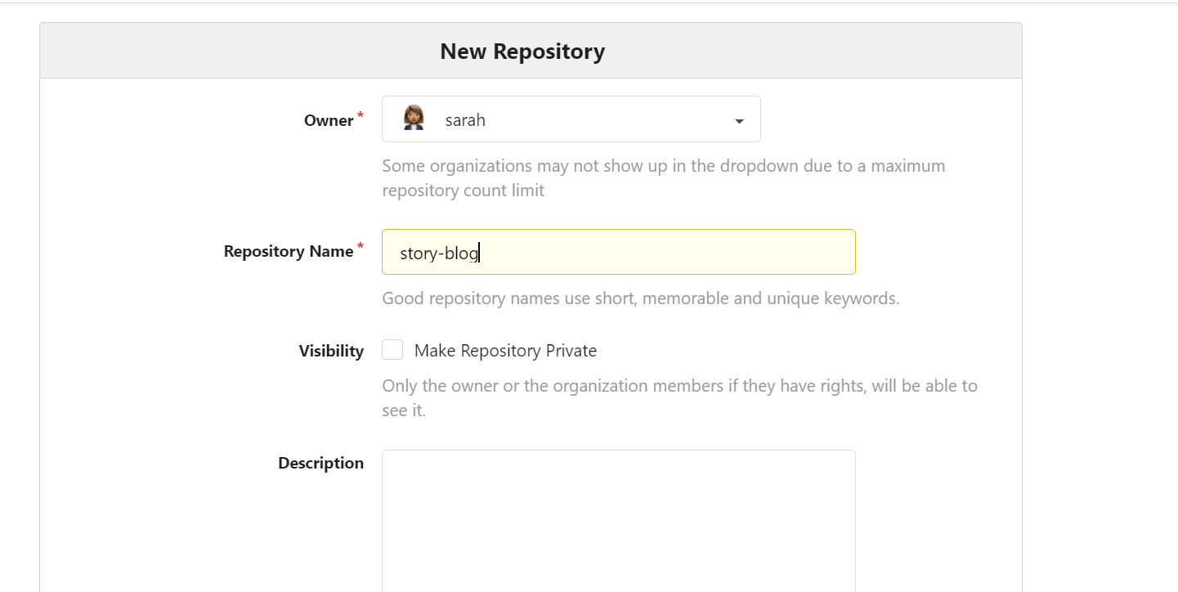

* From within the lab environment (terminal) the remote repository is accessible at the URL http://git.example.com. Let's now configure the remote repository for the local repository at /home/sarah/story-blog

Target remote repo URL : http://git.example.com/sarah/story-blog.git

remote repo alias : origin

Note: This URL won't be accessible from your personal laptop as it is only available within the lab environment.

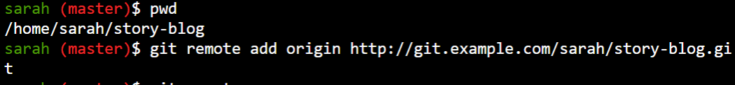

* Which command can be used to push data to our remote repo?

remote repo alias : origin

remote branch : master

git push origin master

* Now push our current stories to the remote git repository we created

Login info:

Username: sarah

Password: Sarah_pass123

remote repo alias : origin

remote branch : master

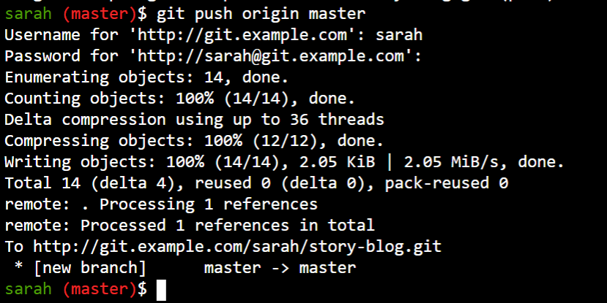

* View the changes in the remote repository using the GUI.

Refresh the remote Gitea page if its already open or click on the Git Portal UI button at the top of your terminal.

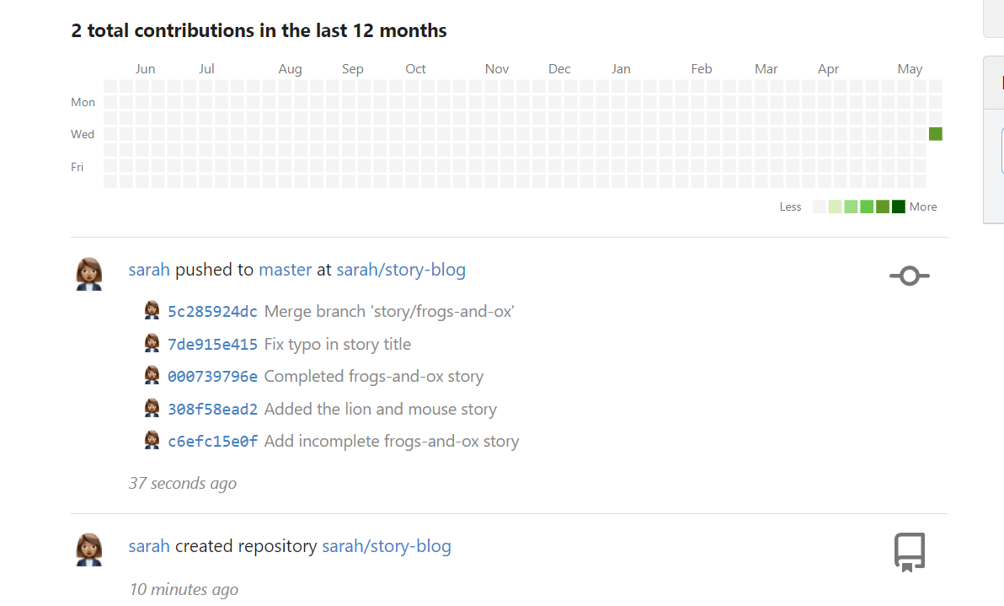

Looking at the remote repository on Gitea can you identify the total disk space consumed by this repository?

Choose the closest option below

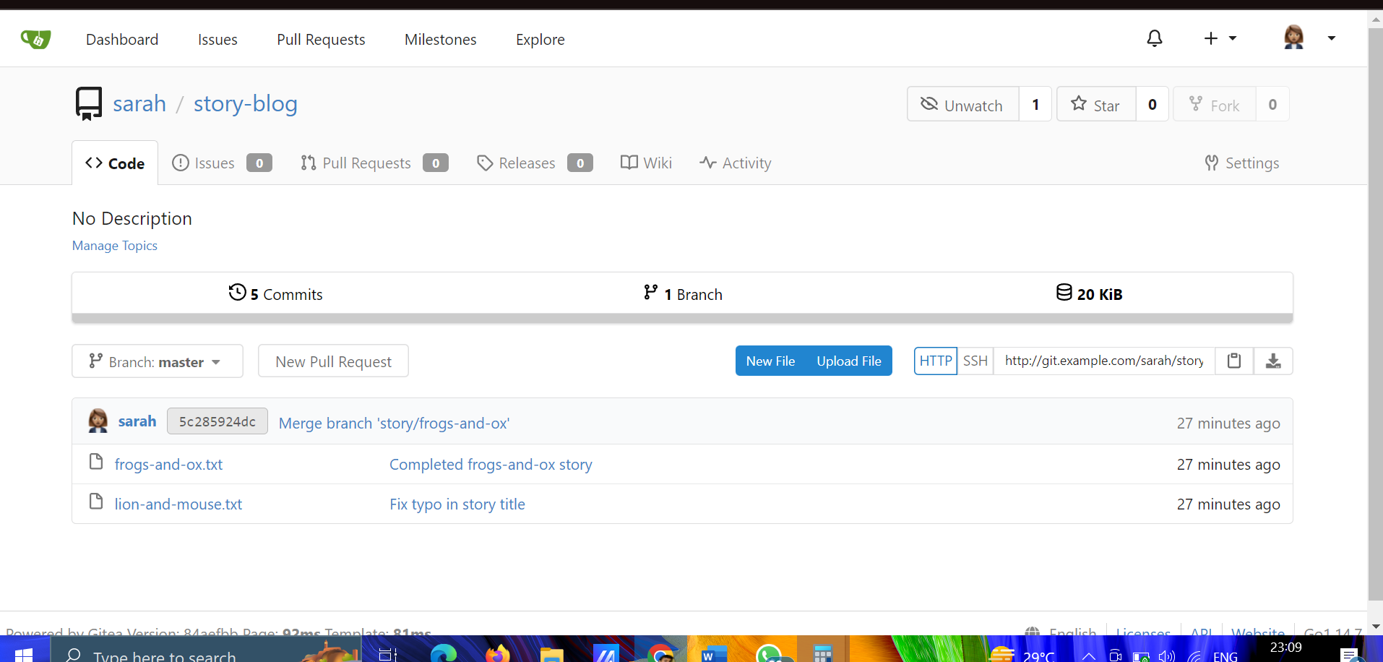

* Let's explore the repositories and teams in our organization and see who is doing what.

How many users can you see in the Gitea tool?

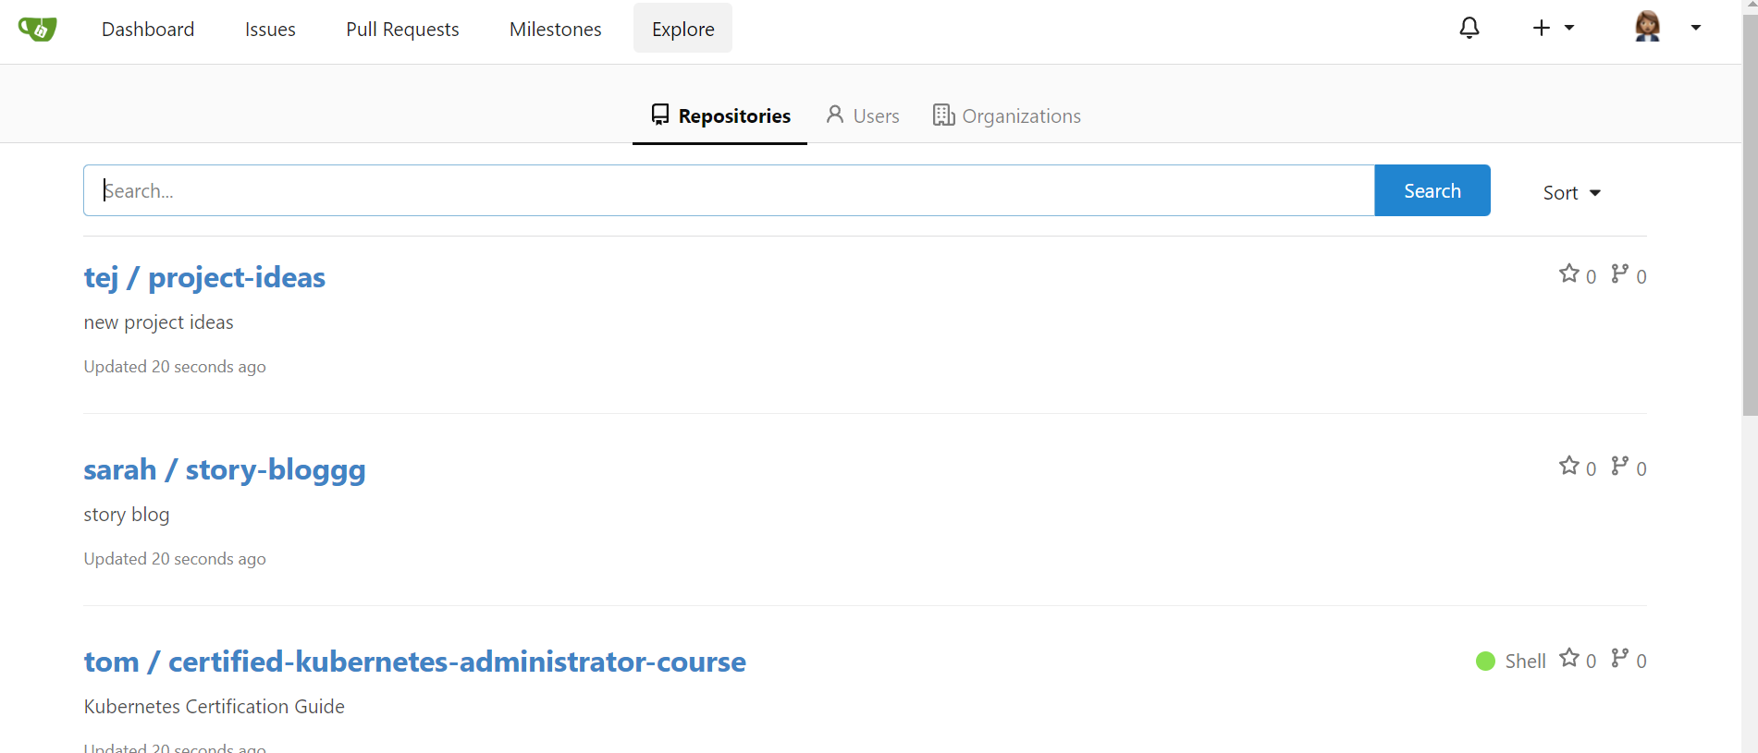

* Tej seems to be working on an ecommerce application. How many commits have been made in that repository?

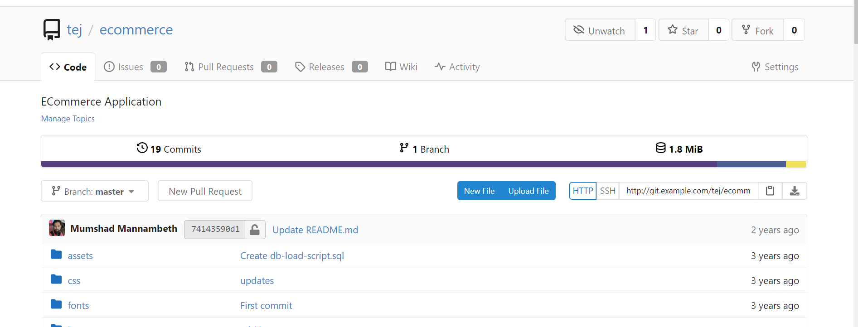

* Sarah seems to have accidentally created a repository for story-blog mis-spelt as story-bloggg. Please delete it.

Select the repository and go to settings.

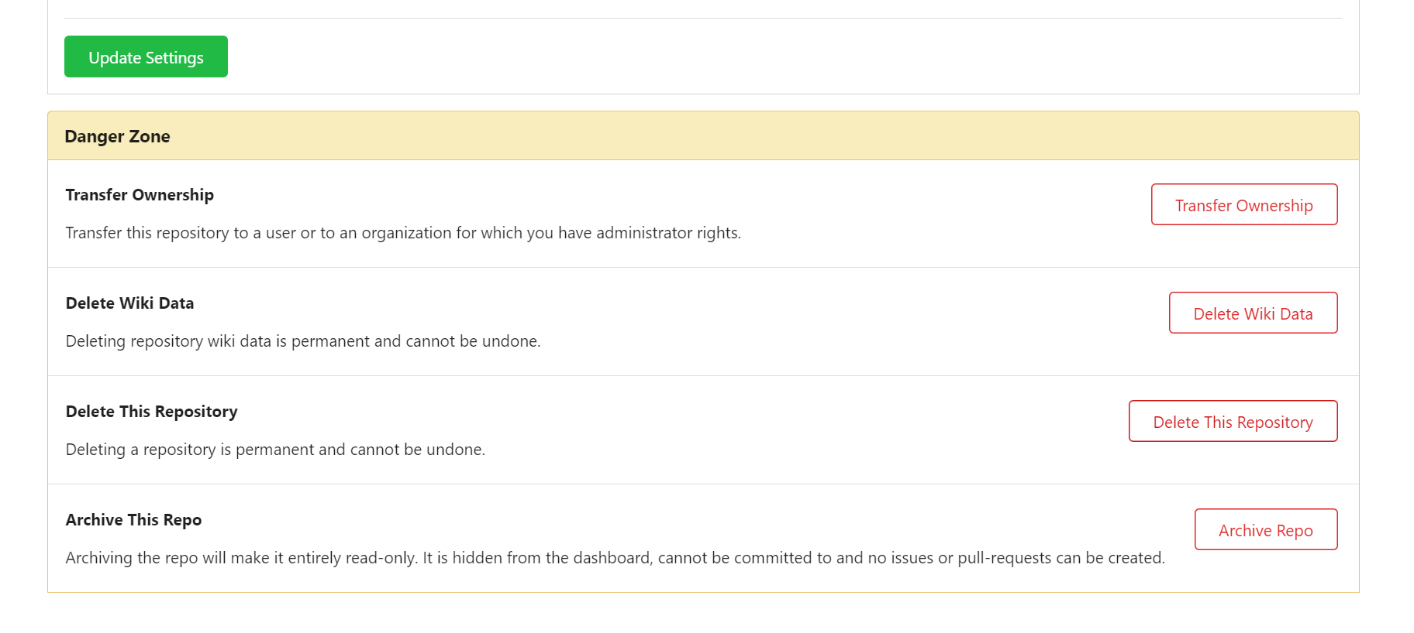

Cloning remote repo

* Max would like to contribute to the story blog. Let's help Max share(push) his story to the remote repository created by Sarah.
* First max needs to download the current code (stories) uploaded by Sarah in remote repository. As user Max, clone the remote repo to his home directory - /home/max

Target repo web URL : http://git.example.com/sarah/story-blog

You can also find this URL from UI

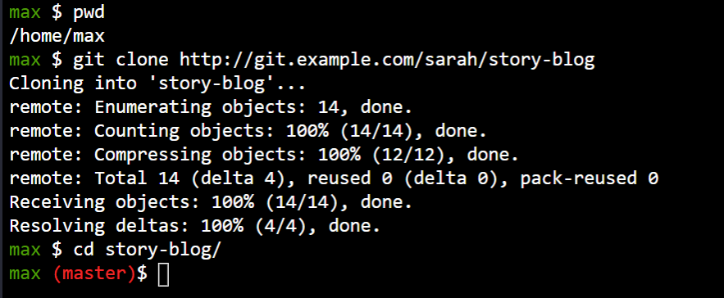

Check the contents of the cloned repository. Confirm that you can see Sarah's story and history of commit by running git log and validate author info, commit message etc.

Max has written his story about The 🦊 Fox and Grapes 🍇

View the file he created and its contents. You may read the story if you wish to. But don't spend all day 😝

* Let us now try to commit the changes. Try to commit the changes with the message Added fox-and-grapes story. And you might get an error that says Please tell me who you are

This is because Max has cloned the repository, but Git doesn't know who Max is. Max needs to tell Git his username and email address. For this use the command git config user.email "max@example.com" and git config user.name "max"

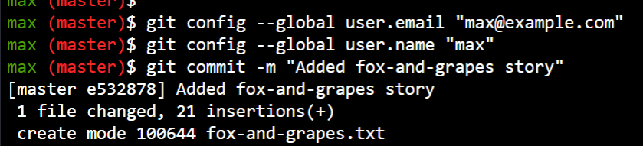

* Great! It's time to push our changes to remote. Do we need to add a remote repository, as Sarah did, before pushing?

Check the configured remotes on the repository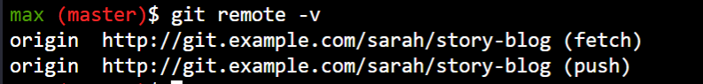

* Now try to push Max's story to remote git repository hosted on Gitea using the below details. If you might run into a permission denied error, proceed to next question.

login info:

Username: max

Password: Max_pass123

remote repo alias : origin

remote branch : master

* If you ran into an issue it is because the repository is public but not everyone can change it. It is public but read-only. To push changes to the repository you need to be a collaborator or a member of the project.

The account owner - Sarah needs to add you as a collaborator. While logged in to the Gitea UI as user sarah go to Settings -> Collaborators of the project and add max as collaborate with Write permissions.  
  
Use Sarah's credentials:  
Username: sarah  
Password: Sarah_pass123

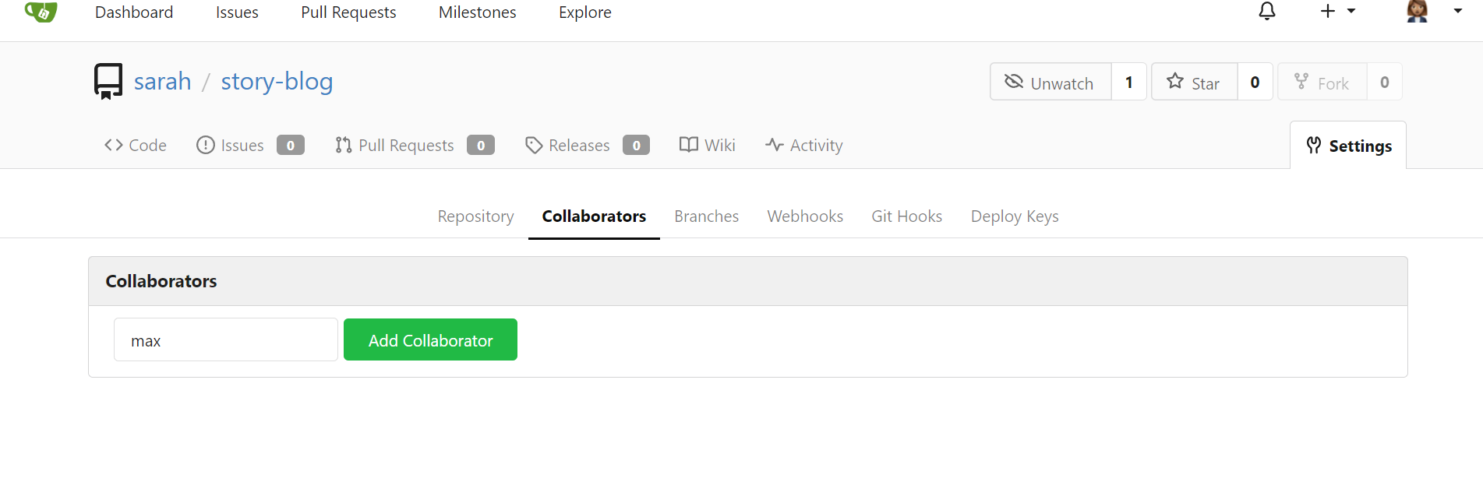

* Now try to push Max's story to remote git repository hosted on Gitea

Login info:

Username: max

Password: Max_pass123

remote repo alias : origin

remote branch : master

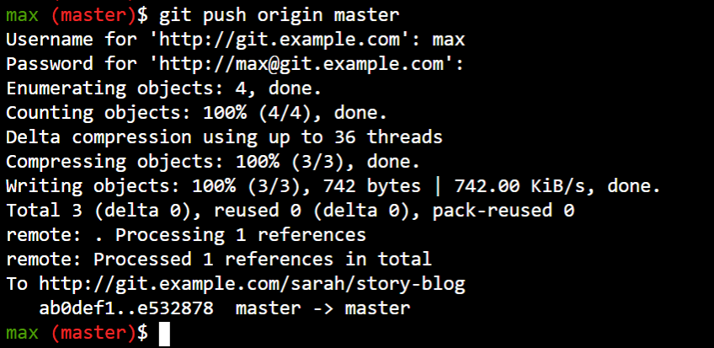

* Confirm the changes in the remote repository using the GUI. Make sure both the stories of Sarah and Max are visible there.

Refresh the remote Gitea page if its already open or click on the Git Portal UI button at the top of your terminal.

Git clone vs git remote add:

git remote add just creates an entry in your git config that specifies a name for a particular URL. You must have an existing git repo to use this.

git clone creates a new git repository by copying an existing one located at the URI you specify.

Pull requests

* In the previous lab we got Max to push his changes to the remote repository. But he pushed them to the master branch directly. We don't want people to do that.

The master branch is the final version of the story. It should always only have content that has been reviewed and approved. We cannot just allow everyone to directly push to the master branch. So let's do it the right way this time.

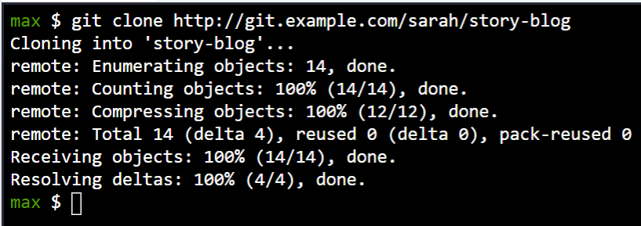

Check the contents of the cloned repository. Confirm that you can see Sarah's story and history of commits by running git log and validate author info, commit message etc.

* Max has written his story about The 🦊 Fox and Grapes 🍇

View the file he created and its contents. You may read the story if you wish to.What's the status of the file in the git repo? 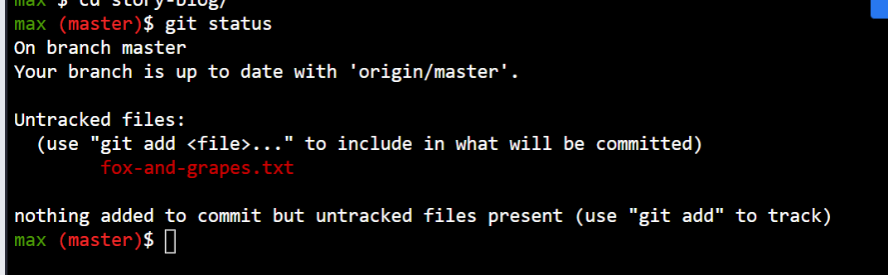

* Unlike last time, let's not commit the story to the master branch directly. Instead commit it to a new branch named story/fox-and-grapes with the commit message 'Added fox-and-grapes story'

Even though you are in master branch already since the file is not tracked you can switch to a new branch and commit the file to the new branch.

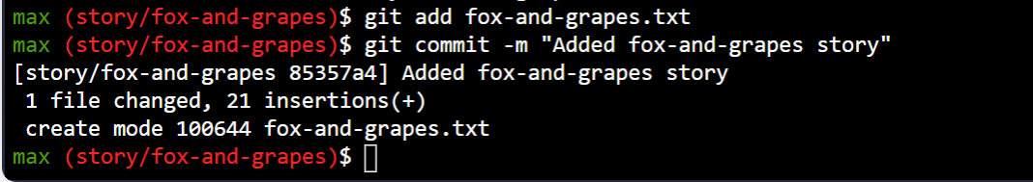

* Now push Max's story to remote git repository hosted on Gitea but to the story/fox-and-grapes branch

Login info:

Username: max

Password: Max_pass123

remote repo alias : origin

remote branch : story/fox-and-grapes

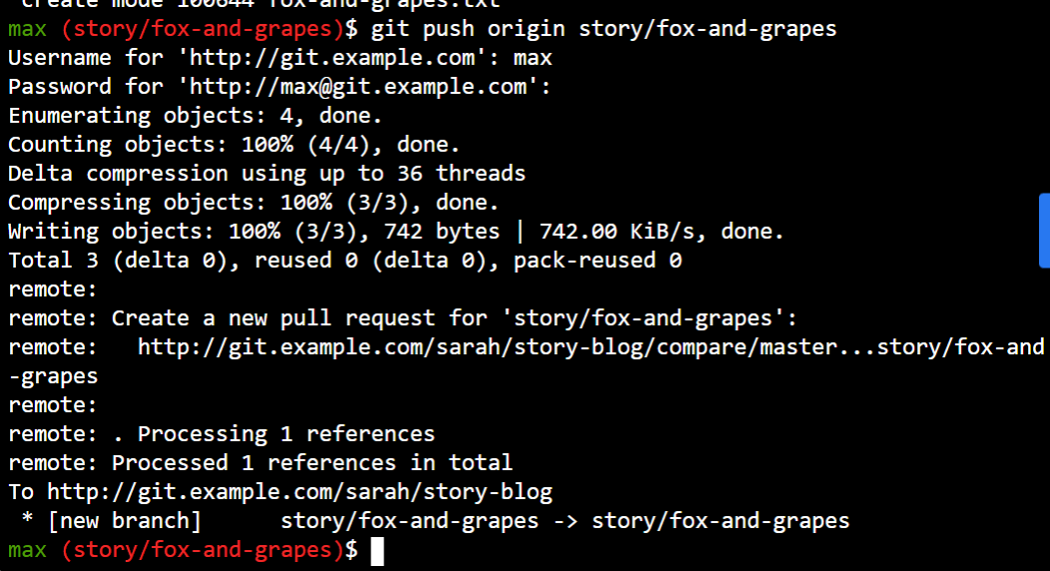

* Max has pushed his story, but his story is still not in the Master branch. Let's create a Pull Request(PR) to merge Max's story/fox-and-grapes branch into the master branch

Click on Git Portal UI to access git UI

UI login info:

* + Username: max
  + Password: Max_pass123

PR title : Added fox-and-grapes story

PR pull from branch: story/fox-and-grapes (source)

PR merge into branch: master (destination)

* Follow below steps to create PR
  + Login to Git Portal UI with max user
  + Go to the story-blog repository
  + Click on Pull requests
  + Click on New Pull request
  + Put PR pull from branch: story/fox-and-grapes
  + Put PR merge into branch: master
  + Click on New Pull Request
  + Add PR title as Added fox-and-grapes story
  + Click on Create Pull request

Before we can add our story to the master branch, it has to be reviewed first. So lets ask tom to review our PR by assigning him as a reviewer

Add tom as reviewer through the Git Portal UI

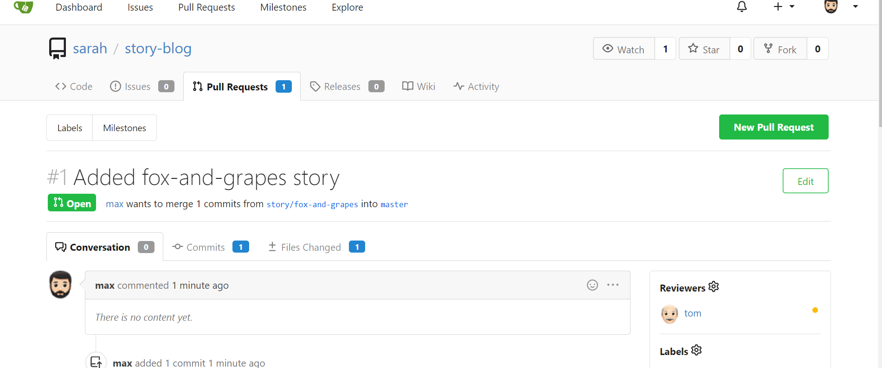

* Now lets review and approve the PR as user Tom

Login to the portal wit h the user tom

Logout of Git Portal UI if logged in as max

UI login info:

- Username: tom

- Password: Tom_pass123

PR title : Added fox-and-grapes story

* Sign out of Git Portal UI as max user
* Login as tom user
* Go to story-blog repo and click on Pull Requests
* Click on the PR - Added fox-and-grapes story
* Click on Files changed tab and then the green drop down button Review. Add any approval message and click on the Approve button to approve the PR. You may need to scroll down to see the Approve button.
* Great stuff!! The story has been approved! 👏. It's now time to Merge the Pull Request to make the story available in the master branch.

Login as user sarah and merge the PR.

- Username: sarah

- Password: Sarah_pass123

- Logout of tom user

- login with the user sarah

- Click on the sarah/story-blog repo

- Go to the Pull Request

- Select the PR

- Click on the green button Merge Pull Request and then confirm again by clicking on the green button Merge Pull Request to merge the PR

- PR status should be shown as Merged

Fetch and pulling

We can update the local repo with the latest changes first fetch n then merge or direct git pull

* In the previous labs we got Max to push his changes to the remote repository. The remote repository now has the 2 stories contributed by Sarah and the one contributed by Max.

Sarah's local repository does not have the new story pushed by Max. Let's update our local repository to be in sync with the remote.  
  
Login credentials for git UI :-  
  
User Name: sarah  
Password: Sarah_pass123

* There are 2 ways to go about this. The first approach is to Fetch the remote branch and Merge it.

From the local repository Fetch the information about the changes in the remote.

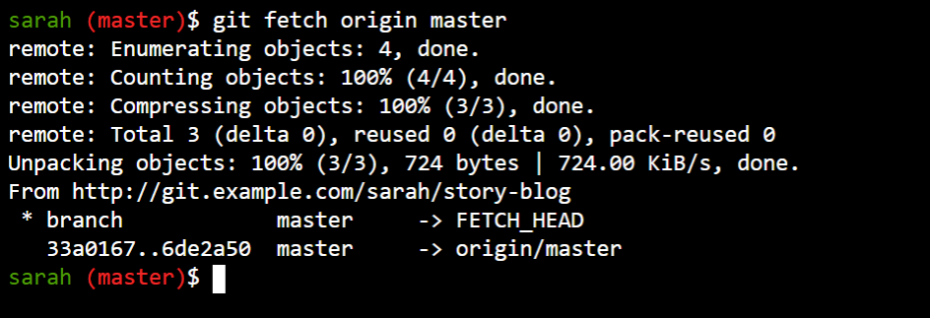

* To view all the branches- both local and remote - run the git branch -a command.

The remote branches have the prefix remotes

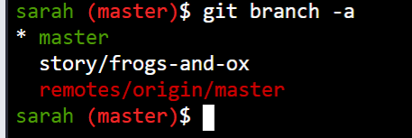

* Now that we’ve fetched the origin master branch, we can update our local master branch with the latest changes made on origin/master branch.  
  Merge the remote master branch to local master

Syntax: git merge <other-branch>

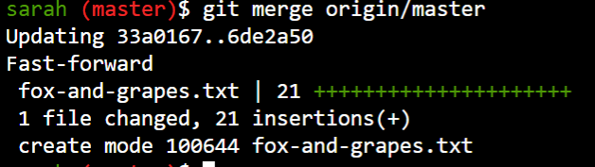

* Max just pushed another story to remote. Let's retrieve that using the second approach. Use git pull origin master to pull all remote changes.

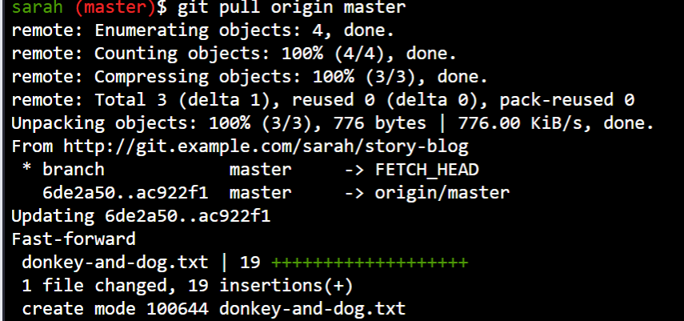

MERGE COMMIT

* Max and Sarah have been contributing stories. And they are available on the remote repository.

Max's local repository has all the latest changes from the remote and is in sync with it. Check it out!

Note: You can Login to git UI with sarah user and password: Sarah_pass123

* During a meeting the team decides to add an Index file to the repository named story-index.txt which would contain a list of all stories written.

It wasn't clear who would own this task, so Max decides to do it himself 💪 . He creates a file named story-index.txt and adds a list of stories to it. Check it out under the /home/max/story-blog directory.

* Let's now stage and commit the story-index.txt file.

Use the message - Add index of stories

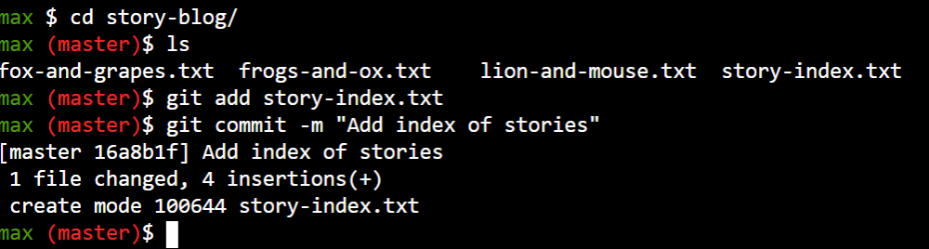

* Let's now push the file to the remote repository.

Try with the git push origin master command, and select the response youget

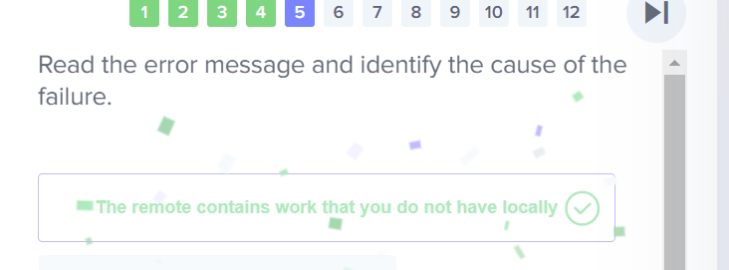

* Looks like someone has pushed changes to the remote that needs to be pulled first, before we can push any of our own changes to remote.

Pull the remote changes.

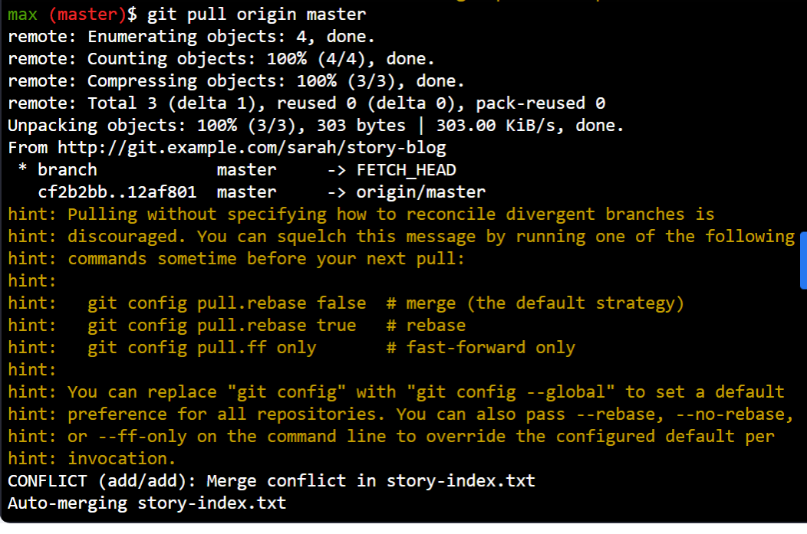

* What was the result of the Pull operation?

Read the last 2 lines of the output of the git pull command.



* We are now in a merge conflict 🙅‍♂️ ! Looks like there was already a file named story-index.txt on remote. Someone beat us to it! Let's find out who.

Check the log of the origin/master branch to see what was the last commit on the repository and identify who added the story-index.txt file.

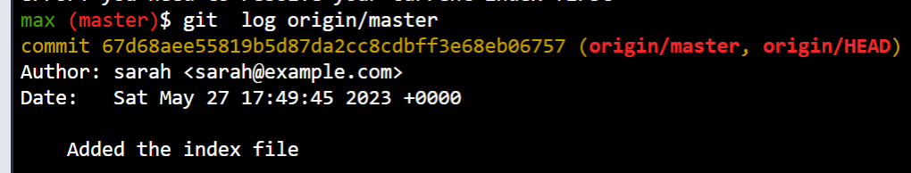

* Looks like Sarah already pushed a version of the file. When we pulled latest changes, git tried to merge Max's and Sarah's versions of the story-index.txt file, but was unsuccessful. However the local story-index.txt file is updated with changes from both Max and Sarah to allow you to merge manually.

Inspect the file (use vi editor or just cat story-index.txt) and select the most appropriate statement below. The first section shows Max's data and the second section shows Sarah's data.

* Looks like both of them were partially wrong. Let's fix the file to remove the errors done by each of them. Let's manually merge changes from both users.

Update the contents of the file (use vi editor) to keep the correct version of the Lion and Mouse story and keep the Donkey and Dog story as well. Remove all the extra lines added by GIT

* Now that we have made a change, we must now commit it.

Commit the current changes with the message - Resolved merge conflicts and merged story index

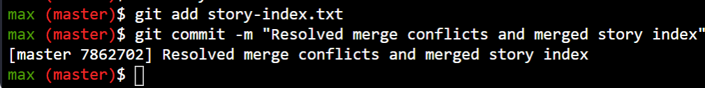

Now that we have merged the changes, everything's clean ✨ . We can now push the changes to remote.

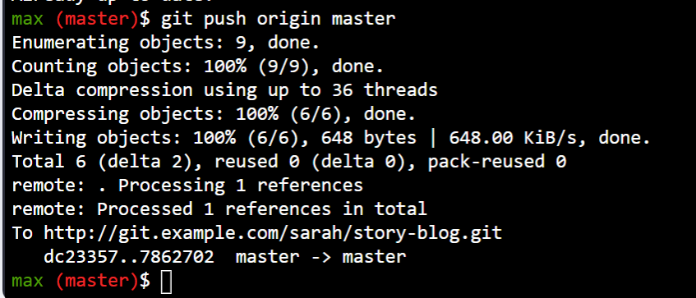

FORK

A new developer, named jon, is not part of the team. However he would like to contribute to the story blog. Lets see how he can contribute in the next steps.

What are the privileges for user jon to the remote story-blog git repo on Gitea UI?

Login to git UI with sarah user and password: Sarah_pass123 and check jon's privileges.

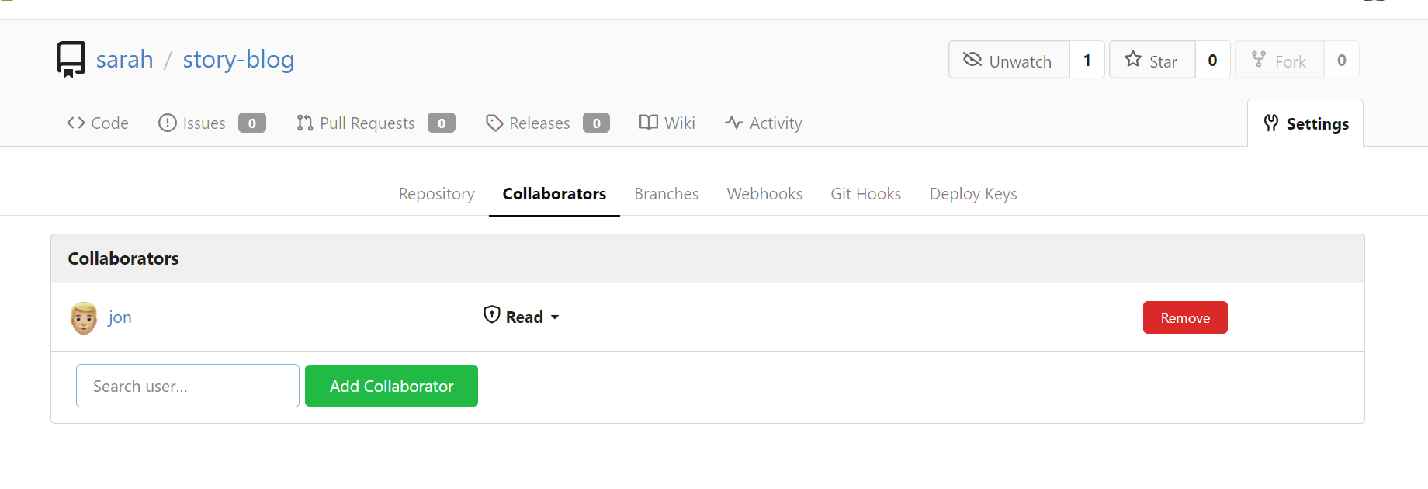

* How can jon add a story to the git repo story-blog?

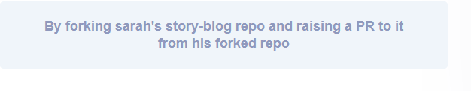

* Login to Git Portal UI with the user jon and fork sarah's story-blog repo
  + Username: jon
  + Password: Jon_pass123

Note: Keep all options default when you fork the repo

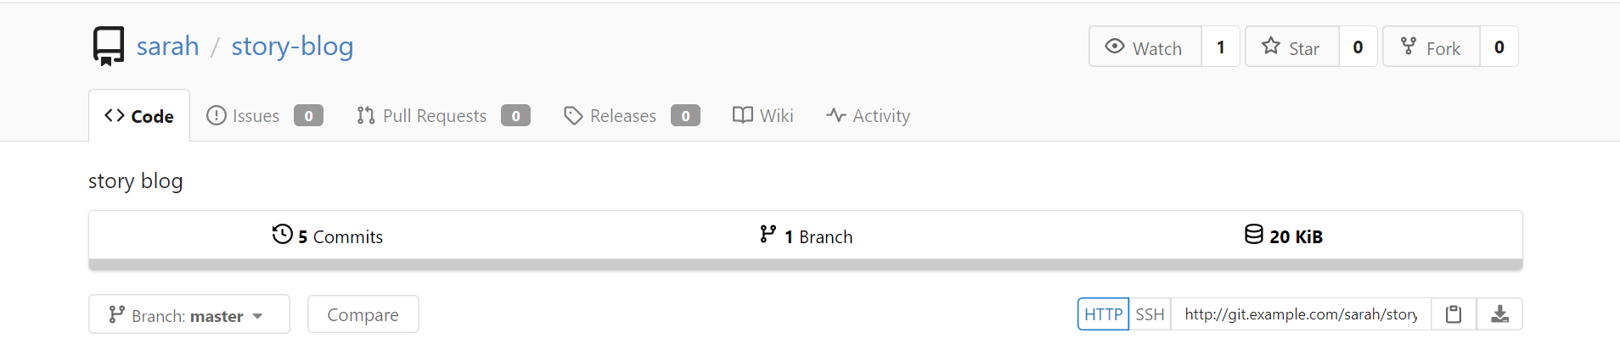

* Click on the Explore button and view the list of repositories. There are now 2 separate repositories. One each in Sarah's and Jon's accounts

Next to the jon/story-blog repo you will see a small fork icon which indicates that its a forked repo.

Ok

* It's now time to add our story to the git repo. For this we first clone the story-blog repository which was forked in previous step to /home/jon/ directory on Jon's system. 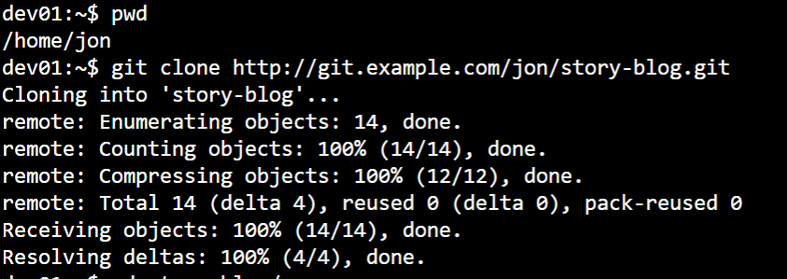
* Push the new changes to the master branch on jon's story-blog repo which was forked in previous step

commit message: Added fox-and-grapes story

* + Username: jon
  + Password: Jon_pass123

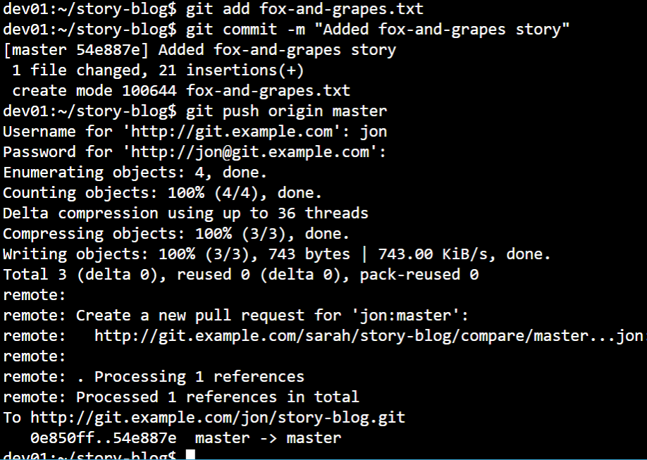

* Raise a PR from jon's forked repo to sarah's repo.

Login to the Gitea UI as user Jon.

* Username: jon

- Password: Jon_pass123

Merge into(destination) branch: sarah:master

Pull from(source) branch: jon:master

PR name: Added fox-and-grapes story

Go to sarah/story-blog or jon/story-blog repo.

Click on Pull requests -> New Pull Request

Select Merge into(destination) branch: sarah:master and Pull from(source) branch: jon:master

To raise a PR click on New Pull Request-> Create Pull Request while keeping other options default

Note that user jon can't merge PR to story-blog repo created in previous step because he only has Read permissions on sarah's repo.

* Hence you can't see a Merge button

As user sarah approve and merge the PR.

User name:sarah

Password: Sarah_pass123

Sign out of jon user.

login with sarah user. Approve and merge PR

fork=opensource

### Git clone vs. fork

When a Git repository is cloned, the target repository remains shared amongst all of the developers who had previously contributed to it. Other developers who had previously contributed to that codebase will continue to push their changes and pull updates from the cloned repository. Any developer who clones a repository can synchronize [their copy of the codebase](https://www.theserverside.com/blog/Coffee-Talk-Java-News-Stories-and-Opinions/How-to-clone-a-git-repository-with-submodules-init-and-update) with any updates made by fellow developers.

In contrast to a clone, a Git fork operation will create a completely new copy of the target repository. The developer who performs the [fork](https://www.techtarget.com/whatis/definition/fork) will have complete control over the newly copied codebase. Developers who contributed to the Git repository that was forked will have no knowledge of the newly forked repo. Previous contributors will have no means with which they can contribute to or synchronize with the Git fork unless the developer who performed the fork operation provides access to them.

A programmer who joins a software development team and plans to contribute back to the codebase will typically clone the target repository. When changes or updates are made, either by the developer or by other members of the team, any clone can be easily synchronized with a [**git push**](https://www.theserverside.com/blog/Coffee-Talk-Java-News-Stories-and-Opinions/How-to-git-push-GitLab-commits-to-origin) or a **git pull**.

A developer who wants to set up a new, separate and isolated project that is based on a publicly accessible Git repo should perform a fork.

REBASING

* Sarah has been working on a new story The Hare and Tortoise for a while now, in the branch story/hare-and-tortoise

Explore the local repository at /home/sarah/story-blog

* Meanwhile her team mates have pushed more stories and updates to the story-index.txt file on the shared central repository.

Check the UI of the remote repository using the Gitea Portal UI button and identify who pushed the last commit.  
  
Use the below credentials:  
Username: sarah  
Password: Sarah_pass123

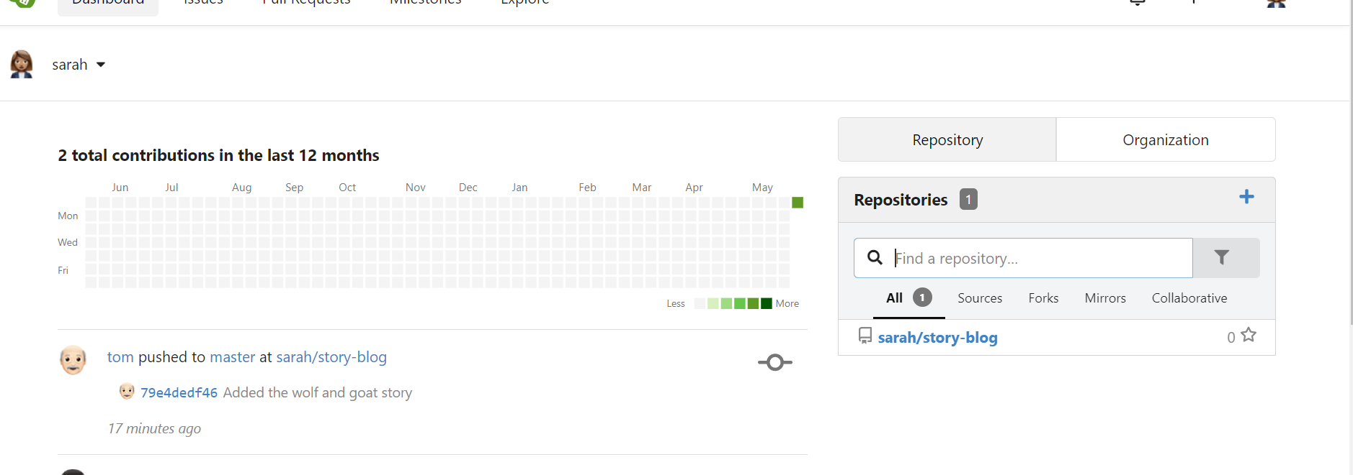

* Let's pull all the changes from remote to our local master branch.

Checkout the master branch and pull changes from remote.

* Great! Now our local master branch has many more commits. Sarah would like to update her working branch - story/hare-and-tortoise - branch with the latest updates.

Sarah is especially looking for the story-index.txt file so that she can update her story to it the clean way and not end up in a merge conflict as it did previously.

* But before we do that, let's check the current status. Check out the story/hare-and-tortoise branch and inspect the files in it.

How many commits do you see in the current branch?

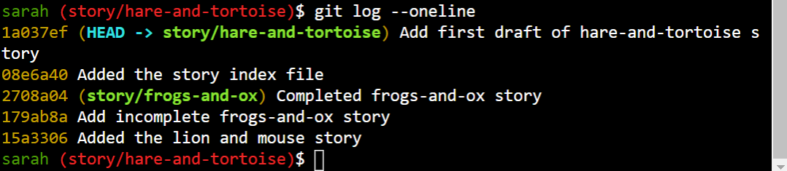

* Let's rebase the story/hare-and-tortoise branch on top of master.
* Checkout the story/hare-and-tortoise branch first and then rebase master.
* Run the command git rebase master
* Awesome! Check the stories and the index file now. It should be up to date with all changes and the git log command should now include the commits from the others users as well.
* Sarah continues to update her story. Check the new commits on story/hare-and-tortoise.
* Run the command git rebase -i HEAD~3 to squash the last 3 commits into 1.

In the editor that opens, leave the first line as is, and change the second and third lines to use squash instead of pick. Then save the file. This way we pick the first commit and then squash the second and third commits to it.

In the next editor window that opens set the commit message to Add hare-and-tortoise story and save it.

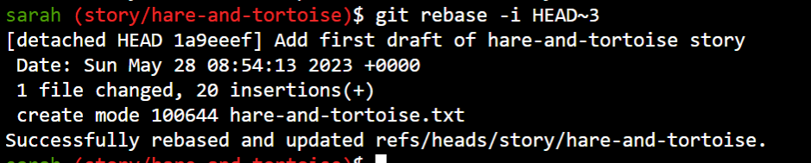

Cherrypicking

* In the previous lab Sarah pulled all the changes pushed by her team and then rebased her branch to stay up to date with the changes.

We have rewinded the lab to the state right before the rebase. Check the contents of the story-index.txt file.

* However, what she was really looking for was only the story-index.txt file on her working branch story/hare-and-tortoise. She does not really want the stories written by her team in her working branch.

She only needs certain commits that were made to update the storyindex.txt file. For this we can simply do a Cherry pick 🍒

* Identify the commit #

On the working branch, cherry pick the commit with the hash identified in the previous step. If you end up in merge conflict, merge the file manually and make sure to leave the latest contents in the story-index.txt file.

Run the command git cherry-pick < commit hash you identified in previous step >

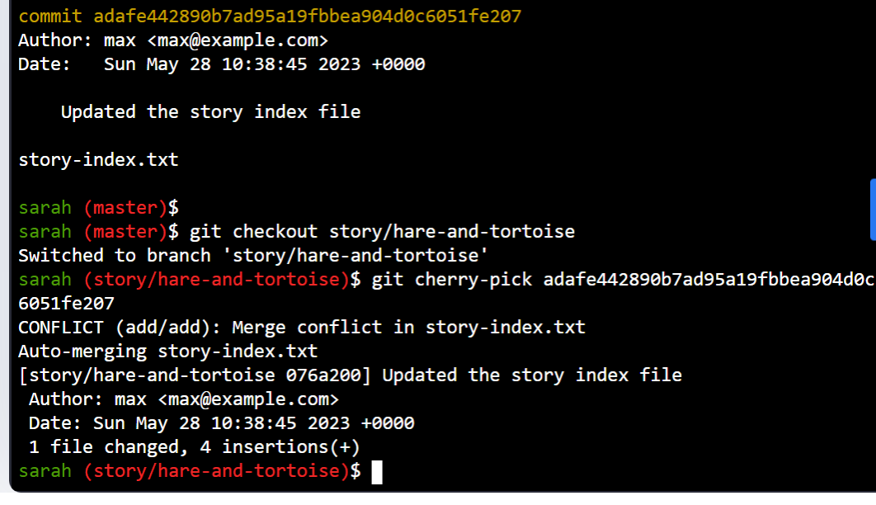

RESETTING OR REVERTING

* Sarah goes through and adds author information to each story and commits them.

Check the previous commit and identify the number of stories Sarah modified.

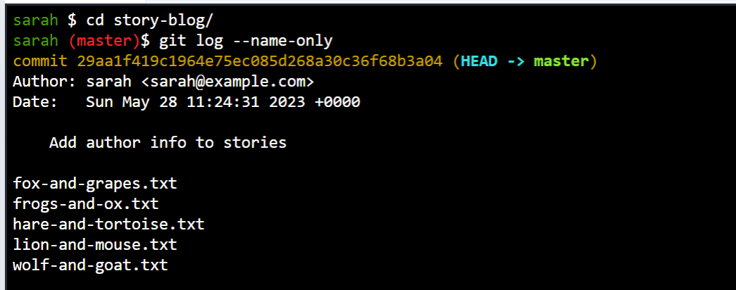

* The publisher informs that the author details need not be added within the story. Instead it would be displayed next to the story on the web page. As such it needs to be removed from within stories 🤦‍♀️

All the changes Sarah made needs to be undone 😩. Help Sarah undo all the changes made in the previous commit. Note that the changes must be retained in the commit history. Use the default revert commit message.

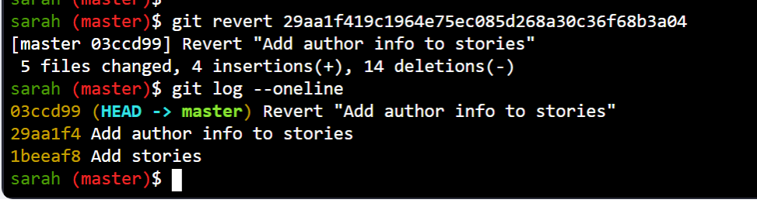

* Which flag of the git reset command can be used to retain changes that were made on target commit after the reset operation?

--soft

* Which flag of git reset command can be used to drop changes that were made on target commit after the reset operation?

--hard

* Sarah has been adding additional content to the Hare and Tortoise story. She accidentally commits the current version before actually finishing the story.

Help Sarah revert the last commit but retain the unfinished changes so that she can continue to finish her story. The last commit must not be part of the GIT history.



* Sarah has now completed her story 😊. Commit the current version of the story with the message 'Finish hare-and-tortoise story'

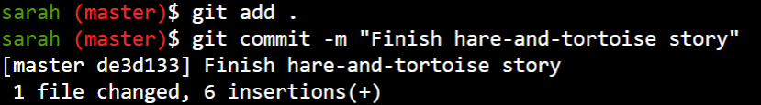

* Sarah decides to improve her story and makes many more commits. Check the logs and count the number of commits she has made since she previously finished her story.

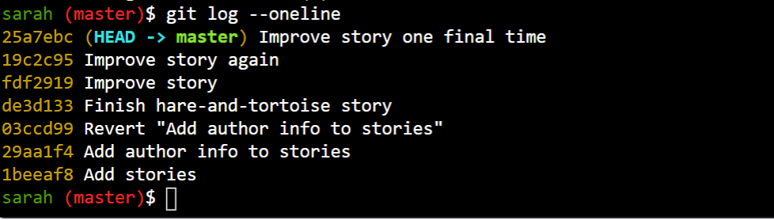

* She takes a short break, and then reads through the new version of her story. But she does not like it 😕. The old version was so much better.

She is so embarrassed 😦 with the new version that she does not want it to be in the commit history at all. Help Sarah reset her story to the previous good version of the story and remove all commits and changes she made since the commit Finish hare-and-tortoise story

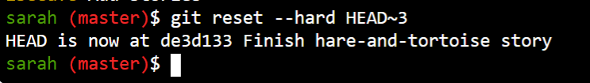

STASHING

* Sarah has been working on the Frogs and Ox story in it's own branch. The story is only half way done, when Max calls her and informs that there's a typo in the Lion and Mouse story.

In the title of the story LION is written as LIOON.

* The current story is not ready to be committed as it's only half done. So let's stash the current changes before heading over to the master branch to fix the typo.



* Checkout master branch and fix the typo in the title of the lion-and-mouse.txt. Commit the changes with the message Fixed title error

The title has the incorrect spelling of LIOON instead of LION

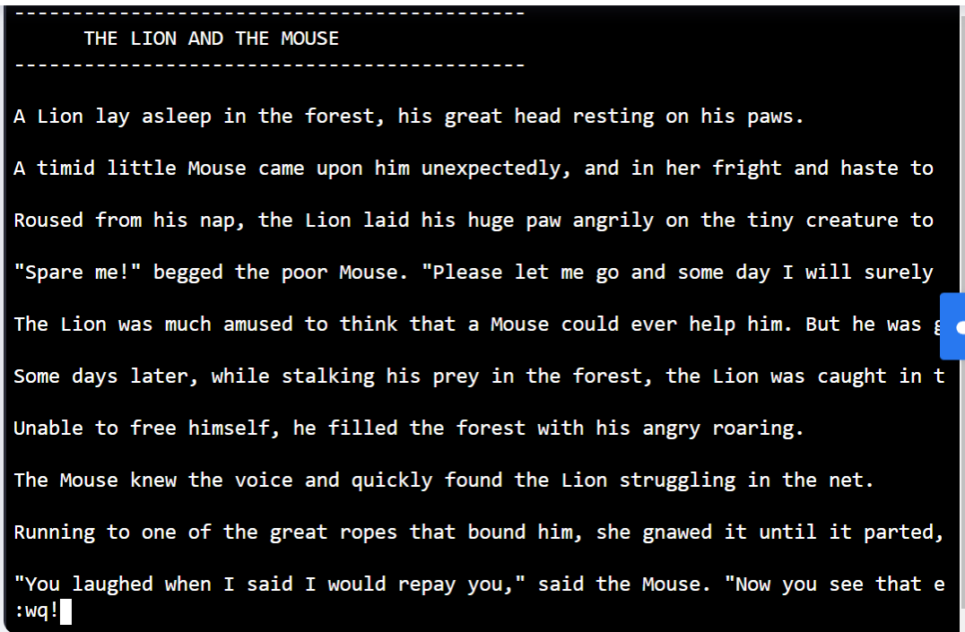

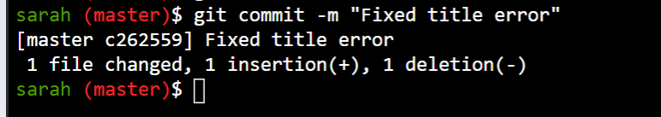

* Now let's go back and continue working on the Frogs and Ox story in the story/frogs-and-ox branch.

Checkout story/frogs-and-ox branch and Pop the stash to retrieve the stashed changes.

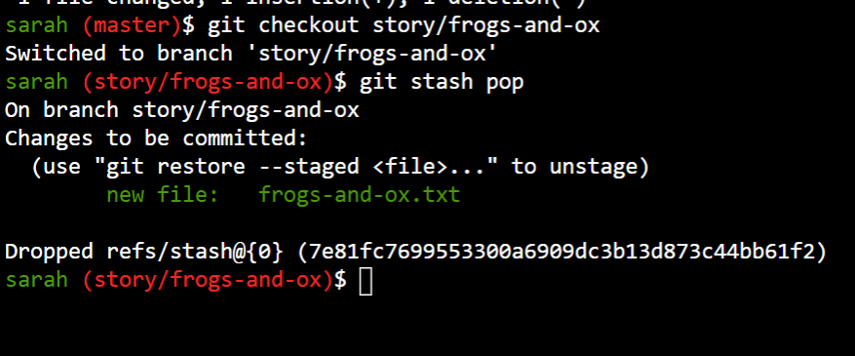

* Sarah just remembered that she had stashed away ideas for a multi-part story in the story/multi-part-story branch a while ago.

Checkout the branch and find the list of stories that were stashed.

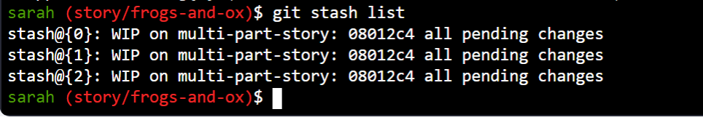

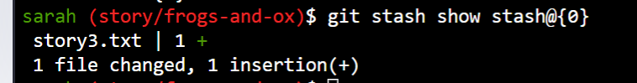

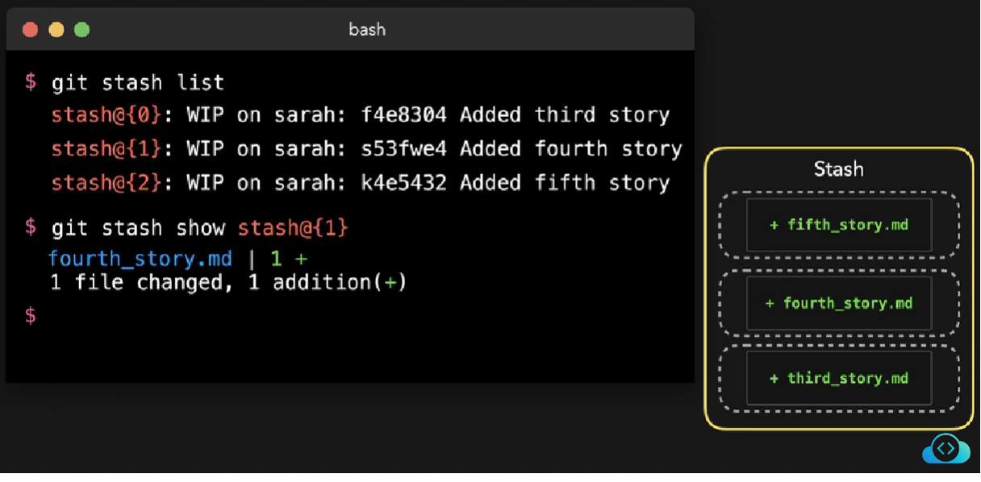

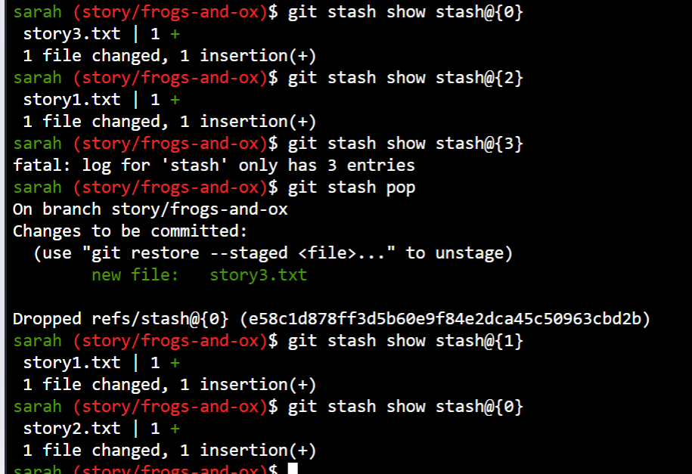

GIT REFLOG

Errors now can be rectified

